India tour 14-30 November 2018
Hotels days 9 and 10
Days 9-10 - Udaipur, located South of Jodhpur some 259klm still in the desert region of Rajasthan.
Thursday 22st November 2018 at the Hotel Trident. Address Trident road, near Pichola Lake, Pichola, Udaipur, Rajasthan.
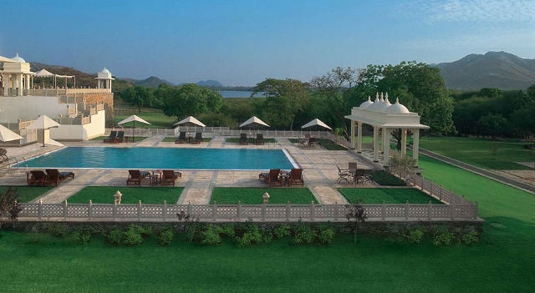
The Trident is a 5 star rated hotel! As can be seen by the standard of the Swimming pool area shown above.
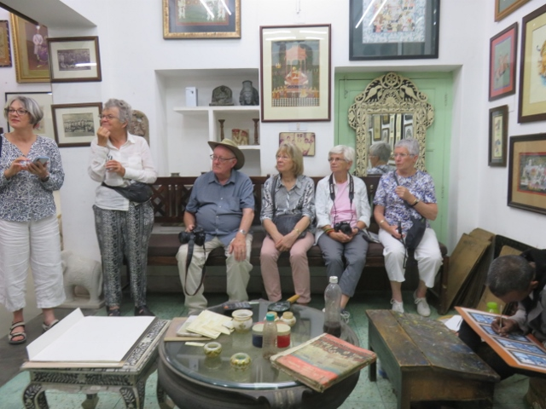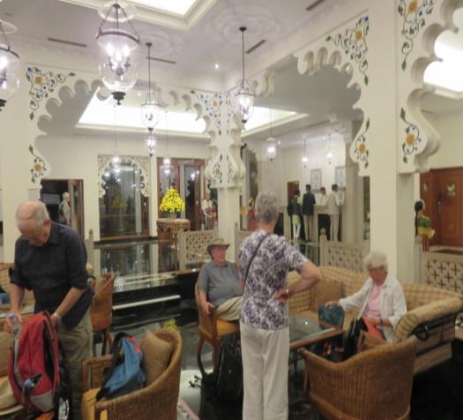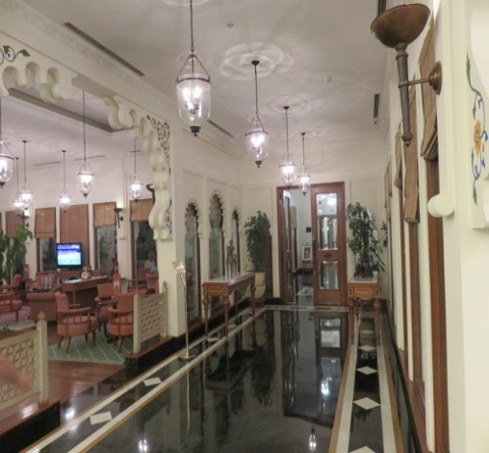
Group nestled in a corner of lounge reception lounges hallway from reception area
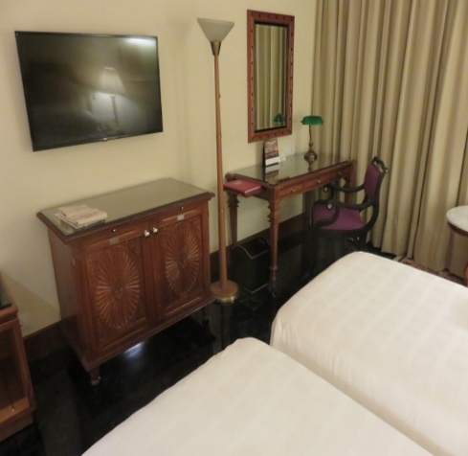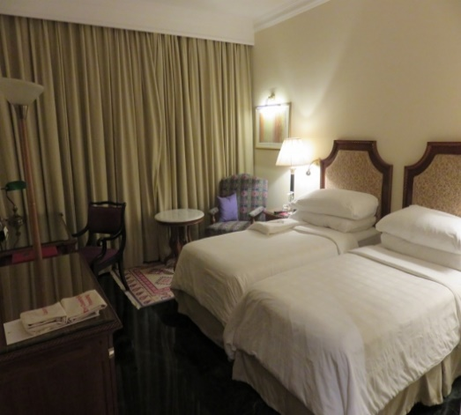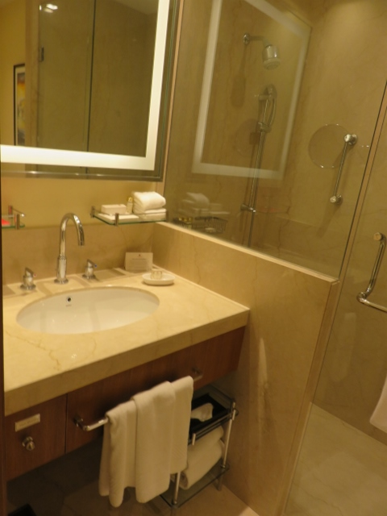
Alan’s room 162 view of beds and curtains bathroom.
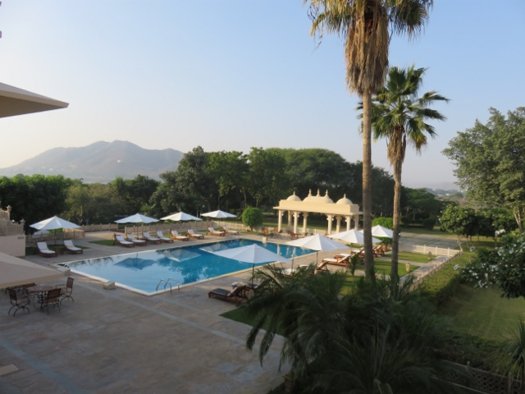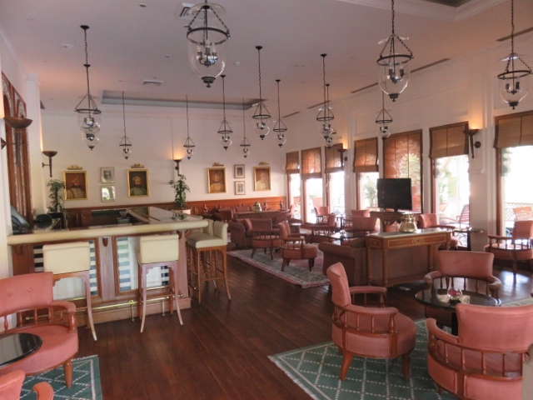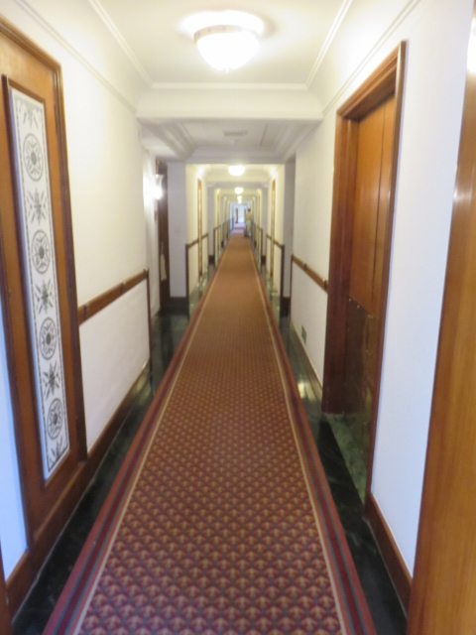
Another aspect of the swimming pool casual bar area long corrridore to rooms.
…………………………………………………………………………………………………………………………………………………………………………………….
The surprise after the first night in the Trident hotel was that the India Tour Company , organising this tour, has changed the hotel venue for the second night in Udaipur. The group was informed of this while boarding the bus for the first of the day’s activities. The group had to exit the bus and given 15minutes to pack travel cases and have them outside door of their room for collection by hotel staff and delivered to the new hotel before resuming the day’s tour.
The Oberoi Udaiviilas hotel is rated a 7 star with an apparent cost per night of $900! The tour company must have made a special deal for this particular tour as there was no additional cost to the tour members.
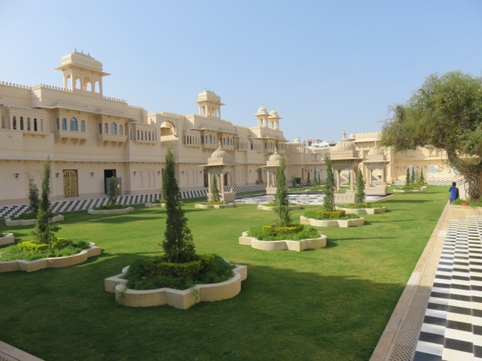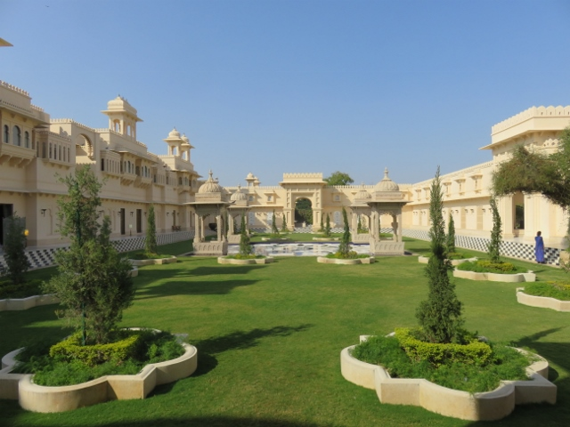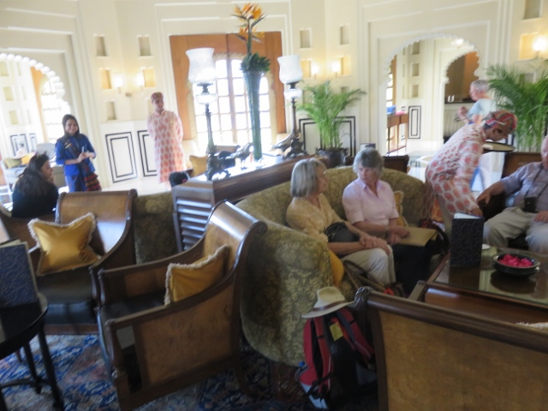
The Oberoi Udaivilas hotel courtyard view in opposite direction tour group in lounge with turbaned staff.
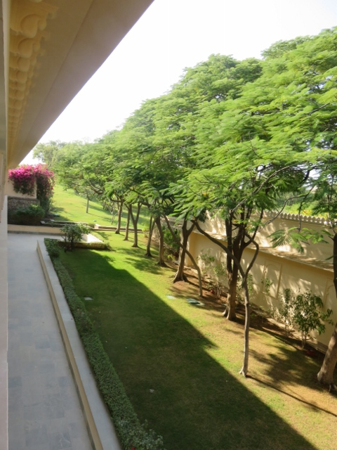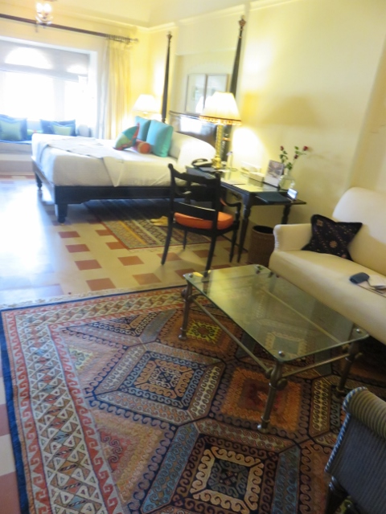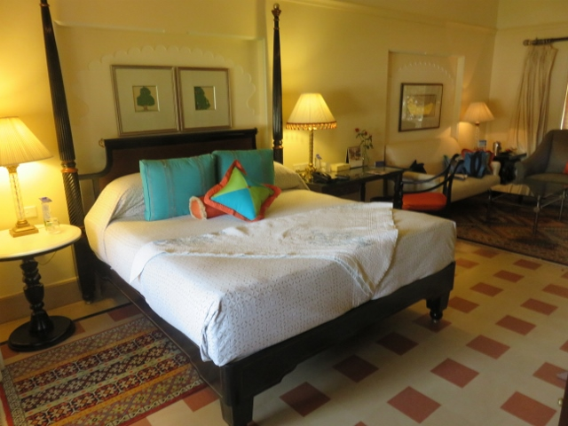
View from deck outside rooms Alan’s room 362 with bay window bed +- lounge area.
Alan’s room/unit opened out into a private courtyard which in turn opened out to a private swimming pool for the use of the residents in that particular block of rooms. The turbaned staff escorted the guests to their room and helped them with the layout, location of devices etc and advising of a butler service 24/7!
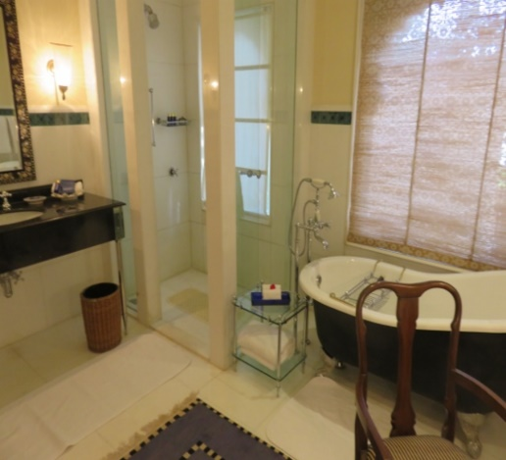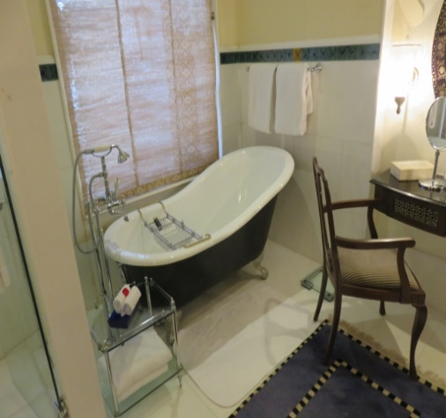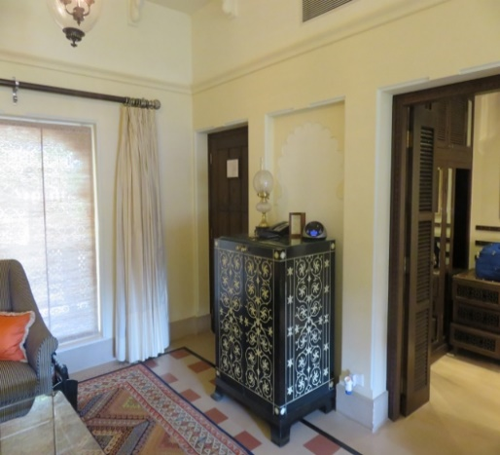
Separate bath and shower & toilet area Bath has a desk & mirrors etc entrance door, cabinet & way to bath.
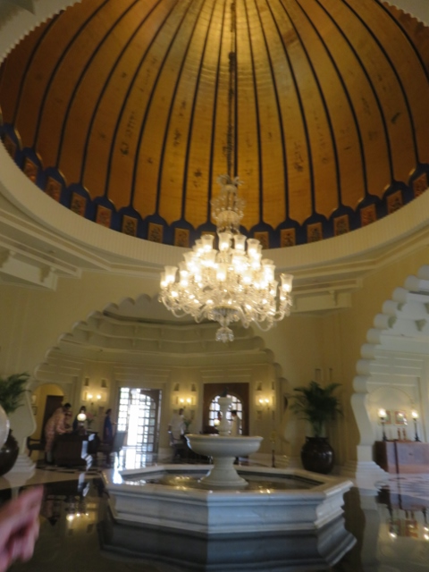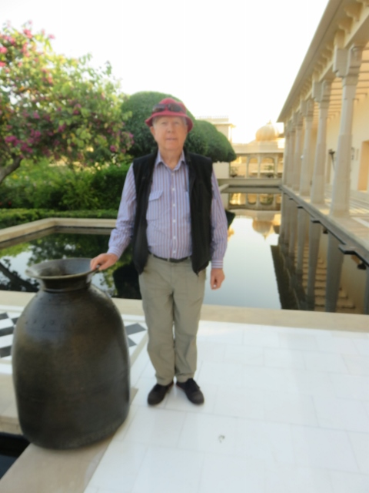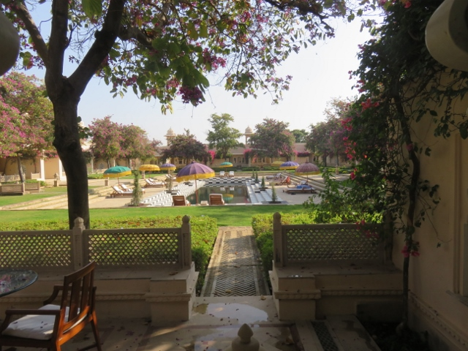
Chandelier in guest lounge area Alan next to another swimming pool exit from Alan’s room to pool area.
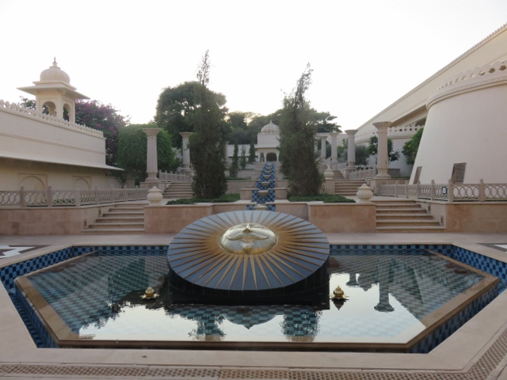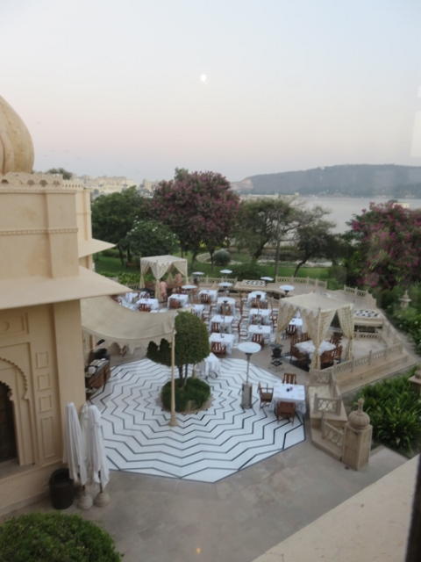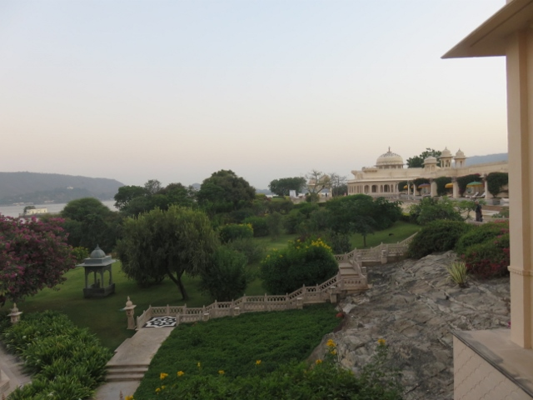
Outside courtyard with water feature Dining area outside View of grounds & Lake Pichola.

This was truly a grand experience! Something that one would not expect to come across on a bucket list anytime soon.
One hic-cup for Alan was on the initial escort by the turbaned staff member to his allocated room, turned out to be a wrong room already occupied! A mix-up with their computer system in listing available rooms was the problem. Soon sorted and the new room 362 accessed. Later that evening on return from the day’s excursions there was a beautiful bottle of local Indian red wine on the lounge table with an apology note with compliments.

